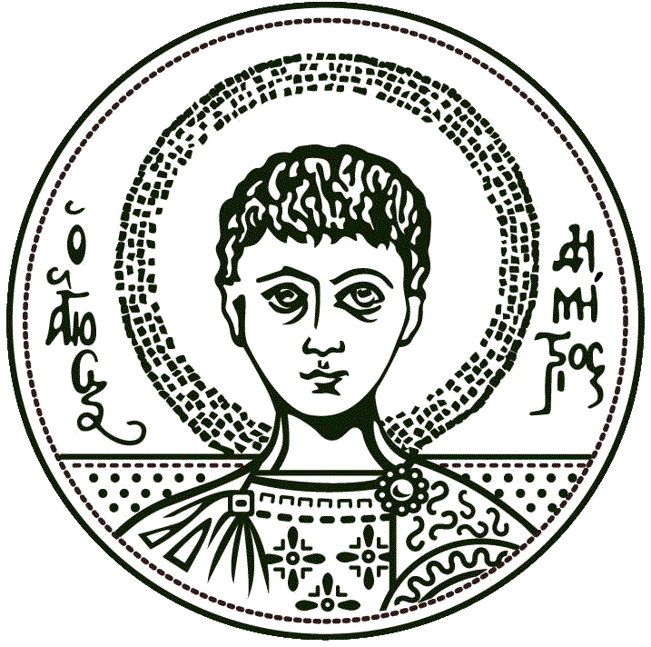
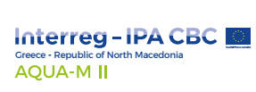
Αριστοτέλειο Πανεπιστήμιο Θεσσαλονίκης
Τμήμα Χημείας

Press Release
Conference-Event «Pollution and Water Quality Management at River Basin Level»
Thessaloniki (Dissemination Centre AUTH), Thursday 28th November 2019

The Department of Chemistry - Aristotle University of Thessaloniki organizes a Conference-Workshop entitled « Pollution and Water Quality Management at River Basin Level» on Thursday 28th November 2019 at the Dissemination Center of Aristotle University of Thessaloniki (3rd Septemvriou Str, AUTH Campus) within the framework of AQUA-M II - Sustainable management of cross-border water resources.
The event aims to the analysis and promotion of topics related to water quality management and control at river basin level, taking into consideration the cross-border challenges as well as the European and national framework.
For your information, please see the event’s invitation and agenda.
We kindly ask you to promote the event.

AQUA-M II in brief
The project AQUA-M II was approved and is being implemented within the framework of the Cross-Border Cooperation Programme Interreg IPA CBC «Greece-Republic of North Macedonia». Project partners are the Municipality of Gevgelija, the Aristotle University of Thessaloniki – Special Account for Research Funds - Department of Chemistry, Municipal Enterprise for Water Supply and Sewerage of Paionia, Municipal Enterprise for Water Supply and Sewerage of Chalikidona and Public Communal Entreprise of Gevgelija. The project aims to contribute to the effective and continuous monitoring of the water quality management of Axios River through the application of joint monitoring and management systems and the strengthening of cooperation among responsible stakeholders and authorities in both countries.

DIMITRA LAMBROPOULOU  Chemistry Department - AUTH  Scientific Responsible  dlambro@chem.auth.gr | IOANNA PAPAIOANNOU  In charge of event organization & communication  on behalf of the Technical Consultant  6937 008036/ contact.iovaconsulting@gmail.com
For more information

